# File Descriptors / redirections

|  |  |  |
| --- | --- | --- |
| /dev/stdin | 0< | **$ cat file.txt**  **$ cat 0< file.txt** |
| /dev/stdout | 1>  >  1>>  >> | **$ cat 1> file.txt**  **$ cat > file.txt**  **$ cat 0< file.txt > /dev/stdout** |
| /dev/stderr | 2>2>> | **$ cat /home/xxx 2> /dev/null** |
|  | &>  &>>  $ command > logs.txt 2>&1  =/= (kolejność ma znaczenie)  $ command 2>&1 > logs.ttx | **$ cat /home/xxx &> logs.txt** |
| "N" is a filename. | M>N | **$ command 2>file.txt** |
| "N" is another file descriptor | M>&N | **$ command 5>&3** |
| Open file "filename"for reading and writingand assign file descriptor "j" to it | [j]<>filename | **#! /bin/bashexec 3<> filename**  **read -n 4 <&3**  **echo -n . >&3**  **exec 3>&-** |
| Heredocs | <<EOF | **$ cat >file.txt <<EOF**  **> xxx**  **> EOF**  **$ cat file.txtxxx** |

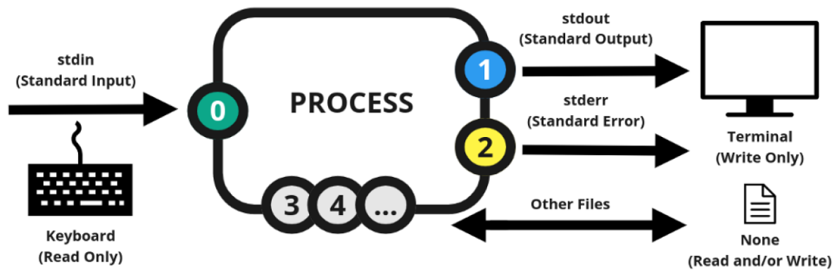

# Named Pipes

|  |  |
| --- | --- |
| Non closing fifo # Create pipe and start reader.  **$ mkfifo pipe**  **$ cat my_pipe &**  # succeeds in keeping the pipe open  # across an arbitrarily complex sequence of commands  **$ exec 3>my_pipe**  # używanie pipa  **$ echo one >&3**  **$ echo two >my_pipe**  # Close pipe.  **$ exec 3>&-** | Transfer large files between processes without temporary files **$ mkfifo -m 0666 /tmp/pipe**  **$ gzip -d < file.gz > /tmp/pipe**  **$ mysql -e "LOAD DATA INFILE '/tmp/pipe' INTO TABLE t1" db1**  Obraz zawierający zrzut ekranu, diagram, Czcionka, linia |

# /proc

https://docs.kernel.org/filesystems/proc.html

/proc - pseudo-filesystem. /proc mirror currently running system and kernel processes and contain information and statistics about them.

|  |  |
| --- | --- |
| **/proc/<PID> folder** |  |
| /proc/$$ | Contains information about a process, where $$ is current process ID ($$ w bash to aktualne PID). |
| /proc/<PID>/cmdline | Command-line arguments used to start the process. |
| /proc/<PID>/cwd | A link to the current working directory of the process |
| /proc/<PID>/environ | environmental variables |
| /proc/<PID>/exe | link to the executable of the process |
| /proc/<PID>/fd | file descriptors,Symbolic links to files opened by the process. |
| /proc/<PID>/limits | contains information about the limits of the process |
| /proc/<PID>/mounts | related information |
| /proc/<PID>/root | link to the work directory of the process |
| /proc/<PID>/status | Detailed status information, including memory usage and process statistics. |

|  |  |
| --- | --- |
| **/proc/net folder** |  |
| /proc/net/route | This is the systems routing table, in HEX format |
| /proc/net/arp | system ARP table, also in HEX format |
| /proc/net/dev | information about sent and received packages |

|  |  |
| --- | --- |
| /proc/sys/net/ipv4/conf/default/forwarding | This file controls if the kernel forwards packets |

|  |  |
| --- | --- |
| **/proc folder** |  |
| /proc/PID | Contains information about a specific process, where PID is the process ID. |
| /proc/self | A symbolic link to the process’s own directory. |
| /proc/cmdline | Kernel command line information. |
| /proc/version | Kernel version, gcc version, and Linux distribution installed. |
| /proc/console | Information about current consoles including tty. |
| /proc/cpuinfo | List information about the CPU(s) on the system, such as the model, speed, and number of cores.. |
| /proc/devices | Device drivers currently configured for the running kernel. |
| /proc/dma | Info about current DMA channels. |
| /proc/fb | Framebuffer devices. |
| /proc/filesystems | Contains a list of all the filesystems that are supported by the kernel. |
| /proc/iomem | Current system memory map for devices. |
| /proc/ioports | Registered port regions for input-output communication with the device. |
| /proc/loadavg | System load average. |
| /proc/locks | Files currently locked by kernel. |
| /proc/meminfo | List details about memory usage and statisticsthat. |
| /proc/misc | Miscellaneous drivers registered for the miscellaneous major devices. |
| /proc/modules | Currently loaded kernel modules. |
| /proc/mounts | List of all mounts in use by the system. |
| /proc/partitions | Detailed info about partitions available to the system. |
| /proc/pci | Information about every PCI device. |
| /proc/stat | Contains a variety of statistics about the system. |
| /proc/swap | Information about swap space. |
| /proc/sys | List configuration and runtime parameters for the kernel. |
| /proc/uptime | Uptime information (in seconds). |